Supplementary material

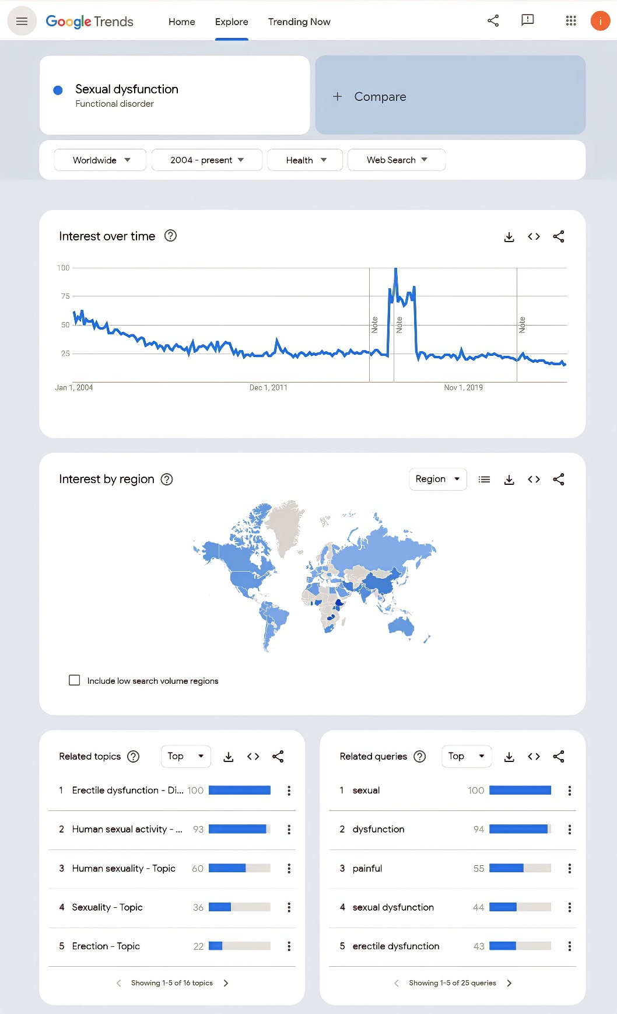
Supplementary Fig. 1. The settings used to determine the most frequently searched words or phrases related to keywords using the Google Trends website are shown in the screenshot.

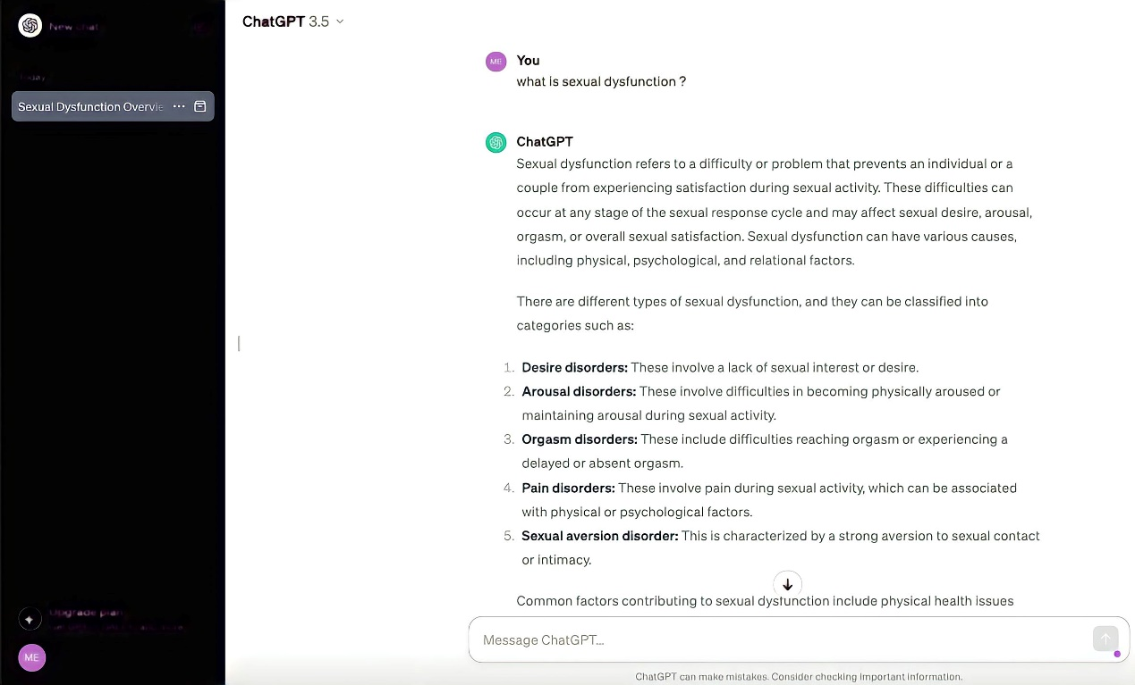
Supplementary Fig. 2. Screenshot of ChatGPT-3.5 asking the given questions and recording the answers.

